Objective:
To download the Debian ISO file and create a bootable USB flash drive using Rufus, then mount the USB drive in VMware Workstation to validate that the drive is bootable.

Requirements:
- A computer with internet access.
- USB flash drive with at least 4GB of storage.
- VMware Workstation installed on the system.

Part 1: Downloading the Complete Debian Installation Image
Step 1: Access the Debian Download Page
- Open your web browser.
- Navigate to the Debian official download page by entering the following URL: https://www.debian.org/distrib/
Step 2: Select the Complete Installation Image
- On the Debian download page, scroll down to the "Download an installation image" section.
- For a more reliable offline installation experience, select the "complete installation image" option.
- Choose the architecture that matches the computers that will be used for the installation. For most modern PCs, this will be the "64-bit PC DVD-1 iso".
Step 3: Download the ISO File
- Click on the "64-bit PC DVD-1 iso" link.
- You will be redirected to a list of mirrors. Select a mirror site close to your geographical location for a faster download.
- Click on the link provided by the mirror site to start the download.
- Save the ISO file to a known location on your computer, such as your "Downloads" folder.
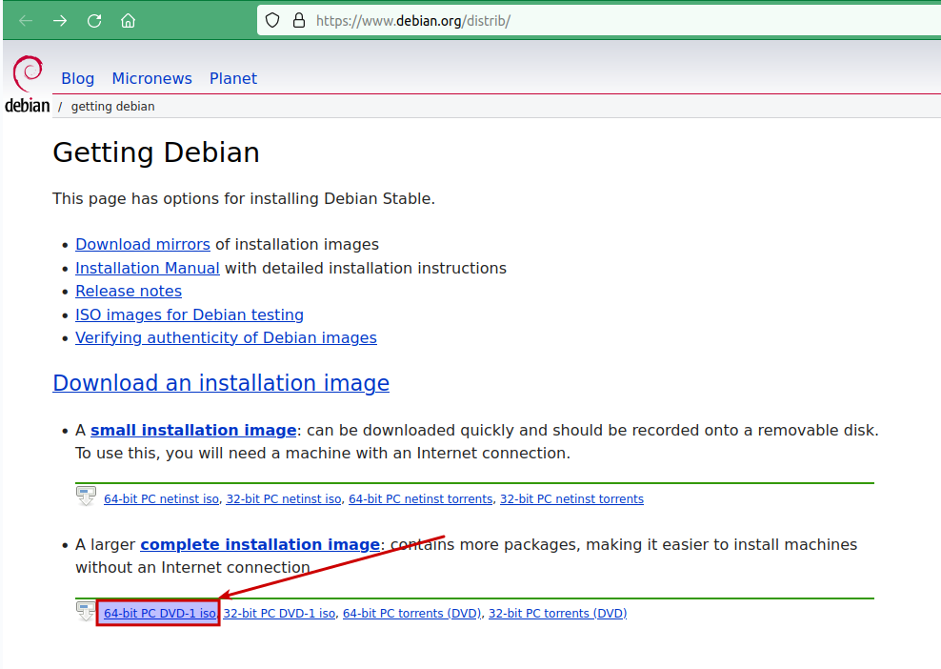

Part 2: Gaining Administrative Access
Step 4: Run Make Me Admin
- Locate the 'Make Me Admin' application on the desktop or in the Start Menu and run it.
- Follow the prompts to grant yourself administrative privileges.
- Once you have administrative access, proceed to download and install Rufus.

Part 3: Making the ISO Bootable on a USB Flash Drive
Step 4: Download Rufus
- Rufus is a free, open-source software used to create bootable USB drives.
- Download Rufus from https://rufus.ie/
- Install and run Rufus on your Windows 10 computer.

Step 5: Prepare Your USB Flash Drive
- Insert the USB flash drive into an available USB port.
- Note: this will erase everything on the USB drive
Step 6: Open Rufus and Configure Settings
- In Rufus, select your USB drive from the "Device" dropdown menu.
- Under "Boot selection," click "SELECT" and browse to the location of your downloaded Debian ISO file.

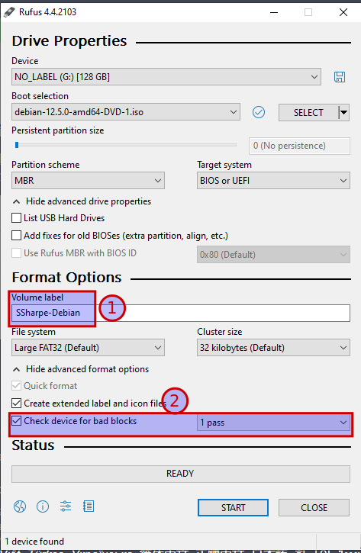
Screenshot 1

1) Set your volume name as First Initial, Lastname-Debian.
As an example Bugs Bunny would be BB-Debian.
2) OPTIONAL: Depending on available time, selecting check for bad blocks 1 pass. Trust me, only enough time in the universe for one pass. These drives are old, so doing a check isn’t a bad idea if you’re hanging around B304 doing homework while it checks your drive. If you see a fault let me know and we’ll dispose of the drive and give you a new one.

Step 7: Start the Flashing Process
- Click "Start" after confirming the settings.
- A warning will pop up stating that all data on the USB drive will be destroyed. Click "OK" to proceed.
- At the ISOHybrid detected dialog box select Write in ISO Image mode (recommended)
- On the next screen, if you get asked to connect to the internet to download additional Syslinux installation files select yes to get these from the internet.
- Wait for Rufus to finish creating the bootable USB flash drive. This may take several minutes to an hour if you select to check for bad blocks.

Part 3: Configuring VMware Workstation to Boot from USB
Step 8: Launch VMware Workstation
- Open VMware Workstation
Step 9: Create a New Virtual Machine
- Click on 'Create a New Virtual Machine'.
- Name this virtual machine: First Initial, Lastname-Debian
- Select 'Custom (advanced)' and click 'Next'.
- Choose 'I will install the operating system later' and click 'Next'.
- Select 'Linux' as the guest operating system and choose 'Debian 12.x 64-bit' from the version drop-down menu. Click 'Next' and continue with the wizard. The USB Controller will automatically be part of the hardware profile.
- You can select the remaining defaults for the rest of the prompts.
Step 10: Change Firmware from BIOS to UEFI
- With the VM powered off, go to the 'VM' menu and select 'Settings'.
- In the 'VM Settings' window, select the 'Options' tab.
- Under the 'Options' tab, go to 'Advanced'.
- In the 'Advanced' settings, look for the 'Firmware Type' section.
- Change the firmware type from 'BIOS' to 'UEFI'. This step is crucial as some systems require UEFI to boot from USB drives.
- Click 'OK' to save the changes.

Step 12: Starting the VM and Connecting the USB Drive
- Power on the virtual machine without the USB drive connected.
- Once the VM is running, go to the 'VM' menu in VMware Workstation.
- Navigate to 'Removable Devices', find your USB drive, and then select 'Connect (Disconnect from Host)'. This action will attach the USB drive to the VM.

Step 13: Booting the VM from the USB Flash Drive
- After the USB drive is connected to the running VM, you may need to reset the VM to recognize the bootable USB drive. You can reset by choosing the 'Reset' option from the VM menu or pressing the reset button in the toolbar.
- As the VM restarts, it should now boot from the USB flash drive into the Debian installer using UEFI firmware.
- If the VM does not automatically boot to the USB, initiate a restart or reset of the VM and quickly press the key to enter the UEFI firmware settings (usually F2 or ESC).
- Within the UEFI firmware settings, navigate to the boot menu, select the USB device as the first boot option, and exit the settings to restart the VM.
- The VM should now boot into the Debian installer from the USB flash drive.
Note for Students:
- Make sure your bootable USB drive is correctly prepared and functioning before attaching it to the VM.
- You must connect the USB drive to the guest VM while the VM is running. Otherwise, the VM may not recognize the device as a bootable medium.
- Changing the firmware from BIOS to UEFI is sometimes necessary for a VM to boot from USB, especially when the USB drive is formatted as MBR.
- The boot order is crucial; ensure the USB drive has priority in the VM's UEFI firmware settings.

Screenshot 2
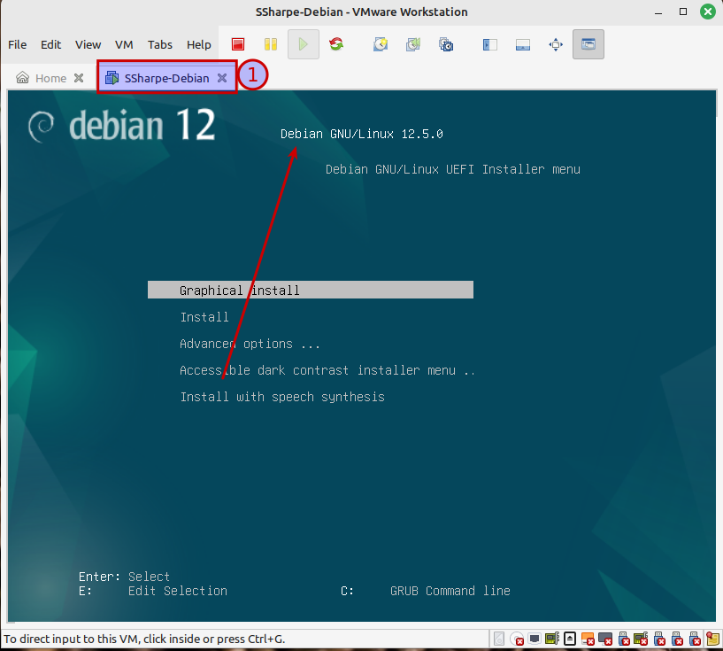
1) Must have your First Initial, Last Name-Debian

2) Should have the Debian installer

